Applying the TEEBAgriFood Evaluation Framework:

Overarching Implementation Guidance

Worksheets

These worksheets follow the activities outlined in Applying the TEEBAgriFood Evaluation Framework: Overarching Implementation Guidance. The Guidance and these worksheets have been developed to assist you in applying the TEEBAgriFood Evaluation Framework. To further assist you, a database of evaluation frameworks, resources, databases, and case studies can be found in the True Cost Accounting Inventory.
To use these worksheets please download or make a copy.

Phase 1: Frame

Step 1: Outline your interest

Step 2: Determine the issue of interest

Step 3: Clarify the purpose

Step 4: Identify stakeholders and form an advisory committee

Step 5: Outline an action plan for your results

Phase 2: Describe and Scope

Step 6: Describe the system

Step 7: Describe the agri-food value chain
Stage | Agricultural Production | Manufacturing and Processing | Distribution, Marketing, and Retail | Household Consumption
Activity
Inputs
Outputs
Location

Step 8: Describe the activities of interest
Agri-food value chain stage
Activities of interest
Methods and practices used to complete the activities

Step 9: Describe the capital stocks
The tables in steps 9-12 build up adding columns as you go. You may wish to start with the full table available in step 12.
Activity
Capital type | Capital managed | Capital used
Natural
Human
Social
Produced

Step 10: Describe the flows
Grey columns should be populated with content from previous steps
Activity
Capital stocks |  |  | Flows: Inputs |  | Flows: Outputs
Capital type | Capital managed | Capital used | Purchased inputs | Ecosystem services | Agri & food outputs | Residuals
Natural
Human
Social
Produced

Step 11: Describe the outcomes
Activity
Capital stocks |  |  | Flows: Inputs |  | Flows: Outputs |  | Outcomes
Capital type | Capital managed | Capital used | Purchased inputs | Ecosystem services | Agri & food outputs | Residuals | Human | Natural | Produced | Social
Natural
Human
Social
Produced

Step 12: Describe the impacts
Activity
Capital stocks |  |  | Flows: Inputs |  | Flows: Outputs |  | Outcomes |  |  |  | Impacts
Capital type | Capital managed | Capital used | Purchased inputs | Ecosystem services | Agri & food outputs | Residuals | Human | Natural | Produced | Social | Environ-mental | Economic | Health | Social
Natural
Human
Social
Produced

Phase 2: Describe and Scope

Step 13: Assess materiality
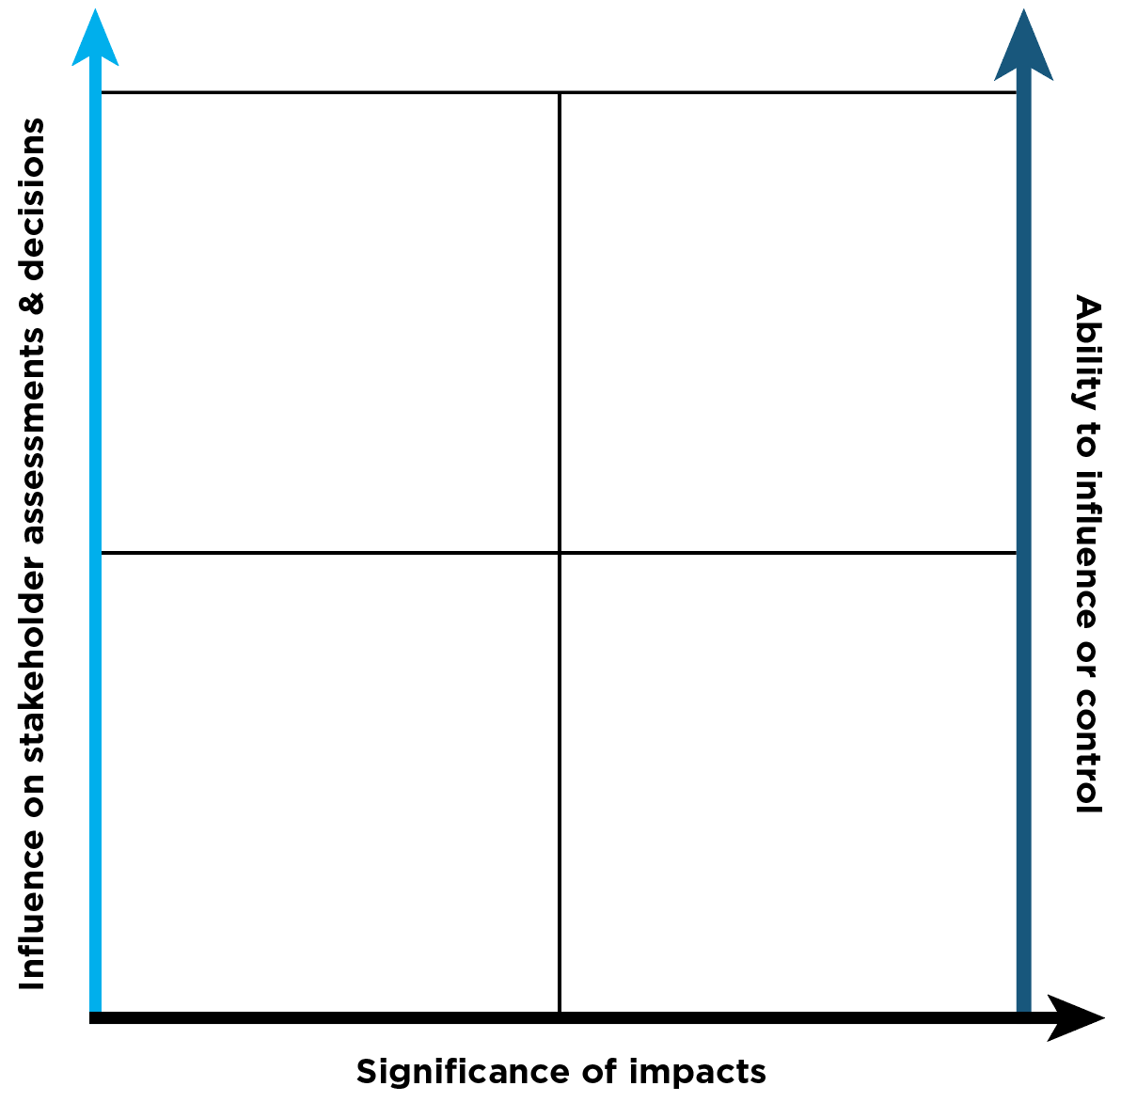 | Environmental | Economic | Health | Social

Step 14: Select impacts for assessment
Environmental  (inclusion/exclusion and reasoning) | Economic  (inclusion/exclusion and reasoning) | Health  (inclusion/exclusion and reasoning) | Social  (inclusion/exclusion and reasoning)

Step 15: Identify opportunities for change

Phase 3: Measure and Value

Step 16: Select an analytical approach and method

Step 17: Select appropriate variables and indicators
Activity
 | Capital stocks |  |  |  | Flows: Inputs |  | Flows: Outputs |  | Outcomes
Measurement | Natural capital | Human capital | Social  capital | Produced capital | Purchased inputs | Ecosystem services | Agri & food outputs | Residuals | Natural | Human | Social | Produced
Variables included
Indicators

Step 18: Collect data and measure
 | Type of indicators
 | Natural capital | Human capital | Social capital | Produced capital
Indicators
Primary data
Secondary data
Modelled data

Step 19: Apply value to your measurement

Step 20: Validate your study and test key assumptions

Phase 4: Take Action

Step 21: Identify who is affected

Step 22: Apply and act on your results

Step 23: Communicate your results

Conclusion
This four-phase process completes the TEEBAgriFood Evaluation Framework application. Recognizing and accounting for the negative and positive environmental, social, and health externalities of food and agricultural systems is a significant contribution toward the creation of healthy and sustainable food systems. We hope you will share your work with governments, farmers, corporations, the finance and investment community, consumers, and other relevant stakeholders to foster action and food systems transformation.
Sharing your system description, study methodology, data, and results with partners and other groups that may benefit helps to inform future and similar studies and improves our collective understanding of eco-agri-food systems. We encourage you to submit your TEEBAgriFood application to the TCA Inventory collection of application case studies. Additionally, consider joining the True Cost Accounting Community of Practice, a vibrant community of stakeholders working collectively to strengthen and mainstream TCA for food systems.
For more information visit www.futureoffood.org or contact tca@futureoffood.org.

